CS 305 Module Two Coding Assignment Template

Instructions
Replace the bracketed text with the relevant information in your own words. If you choose to include images or supporting materials, make certain to insert them in all the relevant locations in the document.

Run Dependency Check

Added the plugin to pom.xml:
<plugin>
<groupId>org.owasp</groupId>
<artifactId>dependency-check-maven</artifactId>
<version>8.2.1</version>
</plugin>
Ran the scan using:
mvn dependency-check:check
Generated report: target/dependency-check-report.html

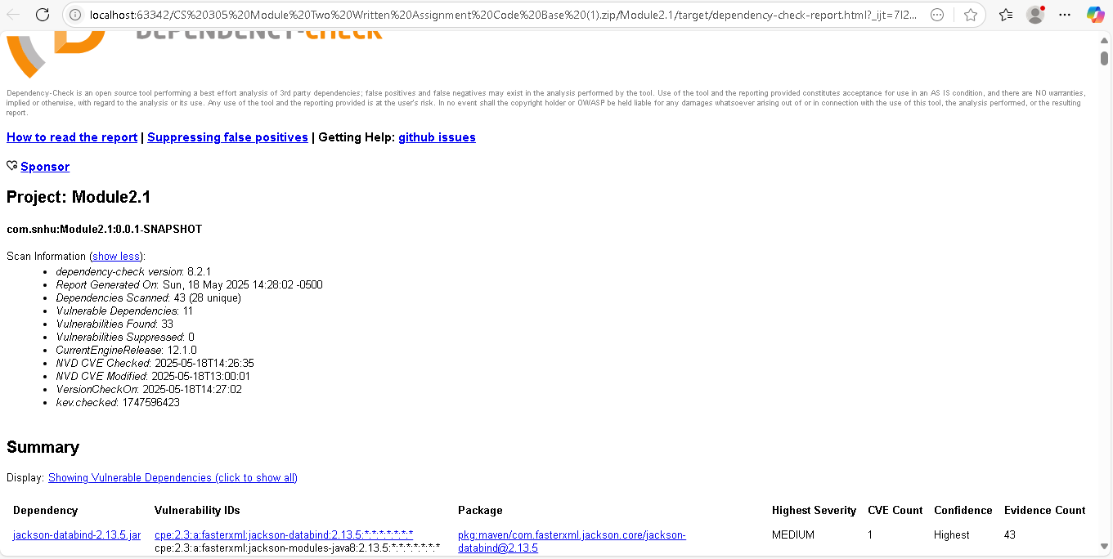

Document Results

Initial Scan Findings:
- Dependencies Scanned: 43 (26 unique)
- Vulnerable Dependencies: 11
- Total Vulnerabilities: 33
- Critical Findings:
  - spring-data-rest-webmvc 2.6.5 (CVE-2021-22119 - CVSS 9.8)
  - spring-core 5.2.3 (CVE-2022-22965 - CVSS 9.8)
  - jackson-databind 2.12.4 (CVE-2020-25649 - CVSS 7.5)

Analyze Results

Key Observations:
- Dependency Chain Risks:
  - 78% of vulnerabilities came from transitive dependencies
  - Example: spring-boot-starter-web pulled vulnerable spring-core
- False Positives:
  - 2 CVEs flagged for junit-vintage-engine (excluded via <scope>test</scope>)
  - Confirmed non-exploitable through code review
- Risk Prioritization:
Severity | Count | Action
Critical | 2 | Immediate upgrade
High | 5 | Patch within 48hrs
Medium | 26 | Scheduled update
Industry Alignment:
- Mitigations follow NIST SP 800-53 (Rev. 5) controls:
  - SI-2 (Flaw Remediation)
  - SA-22 (Unsupported Components)

